MAKERERE UNIVERSITY

COLLEGE OF COMPUTING AND INFORMATION SCIENCES
DEPARTMENT OF NETWORKS
SCHOOL OF COMPUTING AND INFORMATICS TECHNOLOGY

BEE SWARMING AND ABSCONDMENT DETECTION SYSTEM (BSADS)

SOFTWARE DESIGN DOCUMENT (SDD)

Table of Contents

1. INTRODUCTION 1
1.1 Purpose of the Document 1
1.2 Scope of the System 1
1.3 Overview of the Document 2
1.4 Reference Material 4
1.5 Definitions and Acronyms 5
2. SYSTEM OVERVIEW 6
2.1 Problem Statement and System Description 6
2.1.1. Problem Statement 6
2.1.2. System Description 6
2.2. BSADS Context Diagram 7
2.3 Product Functions 8
2.4 User Classes and Characteristics 11
2.4.1. Beekeepers (End Users) 11
2.4.2. Researchers and Analysts 11
2.4 Operating Environment 12
2.4.1. Cloud Data Storage Environment 12
2.4.2. Machine Learning Processing Environment 13
2.4.3 Visualization and Backend Support Environment 13
2.4.4 Mobile Application Environment 13
2.4.5 Communication Infrastructure 14
2.5 Design and Implementation Constraints 14
3. SYSTEM ARCHITECTURE 17
3.1 Architectural Design 17
3.1.1 External Hive Monitoring Interface 17
3.1.2 Data Integration and Communication Subsystem 17
3.1.3 Backend Coordination Subsystem 18
3.1.4 Data Processing and Machine Learning Subsystem 18
3.1.5 Cloud Data Management Subsystem 19
3.1.6 Application Presentation Subsystem 19
3.1.7 Subsystem Collaboration 19
3.1.8 BSADS High-Level Architectural Diagram 21
3.2 Decomposition Description 22
3.2.1 Context-Level Data Flow Diagram (Level 0) 22
3.2.2 Level 1 Data Flow Diagram 23
3.2.3 Structural Decomposition Diagram 25
3.2.4 Data Flow Integrity and Consistency 25
3.3 Design Rationale 26
3.3.1 Rationale for Selected Architecture 26
3.3.2 Trade-offs Considered 26
3.3.3 Alternative Architectures Considered 27
3.3.4 Conclusion 27
4. DATA DESIGN 28
4.1. Data Description 28
4.2 Data Organization by System Component 28
4.2.1 Data Sanitization Component 28
4.2.2 Machine Learning Processing Component 29
4.2.3 Application and Persistent Storage Component 31
4.3 Entity Relationship Structure 33
4.4 Data Integrity and Storage Considerations 34
5. COMPONENT DESIGN 35
5.1 Component Overview 35
5.1.1 Data Integration Component 36
5.1.2 Preprocessing and Feature Extraction Component 37
5.1.3 Machine Learning Inference Component 38
5.1.4 Cloud Synchronization Component 39
5.1.5 System Monitoring and Logging Component 40
6. HUMAN INTERFACE DESIGN 42
6.1 Overview of User Interface 42
6.2 Screen Images 42
6.2.1 Authentication Screens 43
6.2.2 Core Monitoring Screens 45
6.2.3 Alerts and Notifications Screens 48
6.3 Screen Objects and Actions 50
7. REQUIREMENTS MATRIX 52
7.1 Functional Requirements to Components Traceability Matrix 52
7.2 Summary 54

LIST OF FIGURES
Figure 2. 1 System Context Diagram of the Bee Swarming and Abscondment Detection System 9
Figure 3. 1 High-Level Architectural Diagram for BSADS 24
Figure 3. 2 Level 1 Data Flow Diagram for BSADS 29
Figure 3. 3 Structural Decomposition Diagram for BSADS 30

Figure 4. 1 illustrates the logical relationships among core persistent entities. 41
Figure 5. 1 Process Logic for Data Integration Component 45
Figure 5. 2 Processing Logic for 2 Preprocessing and Feature Extraction Component 46
Figure 5. 3 Processing Logic for Machine Learning Inference Component 47
Figure 5. 4 Processing Logic for Machine Learning Inference Component 48
Figure 5. 5 Processing Logic for System Monitoring and Logging Component 49
Figure 6. 1 Landing screen for the mobile application 51
Figure 6. 2 Login screen for the users to access the system 52
Figure 6. 3 Signup screen for new users to register accounts 52
Figure 6. 4 Hive monitoring screen(left) and Dashboard(right) 53
Figure 6. 5 All hives monitoring screen to visualize all hive status(left) and map(right). 54
Figure 6. 6 Hive Details screen and information(left) and More hive Details visualizations(right) 55
Figure 6. 7 Alerts Summary screen 55
Figure 6. 8 Alert Details screen 56

LIST OF TABLES
Table 1.5.1 Definitions and acronyms 6

Table 2. 1 Users of the BSADS system and their technical expertise level 14

Table 4. 1 Raw Acoustic Data Entity 34
Table 4. 2 Raw Environmental Data Entity (Optional) 34
Table 4. 3 Sanitized Audio Metadata Entity (Transient) 35
Table 4. 4 Feature Vector Entity 35
Table 4. 5 Model Metadata Entity(optional) 36
Table 4. 6 Inference Result Entity 36
Table 4. 7 Processed Image Entity 37
Table 4. 8 User Entity 37
Table 4. 9 Hive Entity 38
Table 4. 10 Alert Entity 38
Table 4. 11 Advisory Entity 39
Table 4. 12 Advisory Action Entity (Checklist) 39

Table 7. 1 Requirements Matrix 59

1. INTRODUCTION

1.1 Purpose of the Document
The purpose of this Software Design Document (SDD) is to describe the architectural and detailed design of the Bee Swarming and Abscondment Detection System. This document translates the requirements specified in the Software Requirements Specification (SRS) into a technical design that will guide system implementation.

1.2 Scope of the System
The Bee Swarming and Abscondment Detection System (BSADS) is an Internet of Things (IoT)–based monitoring solution designed to detect early signs of bee swarming and abscondment in beehives. The system shall integrate environmental and acoustic sensors, a machine-learning-based analysis module, and a mobile application to provide real-time insights and alerts to beekeepers.
The operational scope of the system shall begin at the point where raw hive data (acoustic recordings and associated environmental measurements) are retrieved from their storage location, whether collected through deployed sensors or obtained from previously stored datasets. However, not all audio recordings shall be guaranteed to have corresponding environmental parameters. Therefore, the system shall be designed to process acoustic data independently, while incorporating environmental variables only when such data are available.
Once retrieved, the raw data undergoes preprocessing, feature extraction, and analytical processing within a cloud-based or centralized computing platform. The processed data are then subjected to machine-learning–based classification to determine the hive state as one of the following categories: Normal, Pre-swarm, Swarm, Abscondment, or Uncertain. The system further supports real-time data visualization, predictive alert notifications, and historical analysis through a user-friendly mobile application.
The primary goal of the project is to reduce colony loss by enabling early detection of abnormal hive behavior and supporting timely beekeeper intervention. The objectives of the system include improving the accuracy of hive monitoring, minimizing the need for frequent manual inspections, and supporting data-driven decision-making in apiculture.
The key benefits of the system include enhanced colony retention, improved operational efficiency for beekeepers, contribution to apicultural research through long-term data collection, and promotion of smart and sustainable agricultural practices.

1.3 Overview of the Document
This Software Design Document (SDD) provides a detailed description of the design and architecture of the Bee Swarming and Abscondment Detection System. The document translates the functional and non-functional requirements defined in the Software Requirements Specification (SRS) into a structured technical design that guides system implementation.
This Software Design Document (SDD) is organized into seven structured chapters, each addressing a specific aspect of the BSADS design.
- Chapter 1: Introduction presents the purpose, scope, reference materials, and definitions relevant to the system. It establishes the context of the document and clarifies the terminology and standards adopted throughout the design process.
- Chapter 2: System Overview provides a high-level description of the BSADS system, including the system context diagram, product functions, user classes and characteristics, operating environment, and design and implementation constraints. This chapter describes the overall functionality and positioning of the system before detailing its internal structure.
- Chapter 3: System Architecture describes the architectural design of the system. It includes the architectural model, subsystem decomposition, data flow diagrams, structural decomposition, and the rationale behind architectural decisions. Trade-offs and alternative architectural approaches considered during the design phase are also discussed.
- Chapter 4: Data Design defines how system data is structured and managed. It includes detailed descriptions of data entities, data organization, and the system data dictionary, specifying attributes and relationships among core entities such as users, sensor data, inference data, and alerts.
- Chapter 5: Component Design provides a detailed description of individual system components, including data integration, preprocessing and feature extraction, machine learning inference, data storage, cloud synchronization, backend services, mobile application modules, and system monitoring. Each component’s purpose, inputs, outputs, responsibilities, and processing logic are defined.
- Chapter 6: Human Interface Design describes the user interface structure of the system, including authentication screens, monitoring dashboards, alert displays, and configuration interfaces. This chapter defines screen objects, user actions, and interaction flow between users and the system.
- Chapter 7: Requirements Matrix: Provides a traceability matrix to ensure all functional requirements from the SRS are addressed within this design.
Together, these chapters provide a comprehensive technical blueprint that supports system development, testing, deployment, and maintenance.

1.4 Reference Material
[1] “BSADS – Software Requirements Specification (SRS).”
[2] A. Kviesis, V. Komasilovs, N. Ozols, and A. Zacepins, “Bee colony remote monitoring based on IoT using ESP-NOW protocol,” PeerJ Comput. Sci., vol. 9, p. e1363, Apr. 2023, doi: 10.7717/PEERJ-CS.1363.
[3] H. Human, S. W. Nicolson, and V. Dietemann, “Do honeybees, Apis mellifera scutellata, regulate humidity in their nest?,” Naturwissenschaften 2006 93:8, vol. 93, no. 8, pp. 397–401, May 2006, doi: 10.1007/s00114-006-0117-y.
[4] A. Michelsen, W. F. Towne, W. H. Kirchner, and P. Kryger, “The acoustic near field of a dancing honeybee,” Journal of Comparative Physiology A, vol. 161, no. 5, pp. 633–643, Sep. 1987, doi: 10.1007/BF00605005.
[5] “Honeybee Democracy.” Accessed: Feb. 19, 2026. [Online]. Available: https://www.degruyterbrill.com/document/doi/10.1515/9781400835959/html
[6] E. Stalidzans and A. Berzonis, “Temperature changes above the upper hive body reveal the annual development periods of honey bee colonies,” Comput. Electron. Agric., vol. 90, pp. 1–6, Jan. 2013, doi: 10.1016/j.compag.2012.10.003.
[7] S. Gil-Lebrero, F. Quiles-Latorre, M. O.-L.- Sensors, and undefined 2016, “Honey bee colonies remote monitoring system,” mdpi.comS Gil-Lebrero, FJ Quiles-Latorre, M Ortiz-López, V Sánchez-Ruiz, V Gámiz-LópezSensors, 2016•mdpi.com, Accessed: Feb. 19, 2026. [Online]. Available: https://www.mdpi.com/1424-8220/17/1/55
[8] A. Z.- Sensors and undefined 2019, “Bee swarm activity acoustic classification for an IoT-based farm service,” mdpi.comA ZgankSensors, 2019•mdpi.com, Accessed: Feb. 19, 2026. [Online]. Available: https://www.mdpi.com/1424-8220/20/1/21
[9] W. G. Meikle and N. Holst, “Application of continuous monitoring of honeybee colonies,” SpringerWG Meikle, N HolstApidologie, 2015•Springer, vol. 46, no. 1, pp. 10–22, Jan. 2015, doi: 10.1007/s13592-014-0298-x.
[10] D. Mezquida, J. M.-S. journal of agricultural, and undefined 2009, “Platform for bee-hives monitoring based on sound analysis. A perpetual warehouse for swarm apos; s daily activity,” sjar.revistas.csic.esDA Mezquida, JL MartínezSpanish journal of agricultural research, 2009•sjar.revistas.csic.es, Accessed: Feb. 19, 2026. [Online]. Available: https://sjar.revistas.csic.es/index.php/sjar/article/view/1109
[11] M. Bencsik, J. Bencsik, M. Baxter, … A. L.-… and electronics in, and undefined 2011, “Identification of the honey bee swarming process by analysing the time course of hive vibrations,” ElsevierM Bencsik, J Bencsik, M Baxter, A Lucian, J Romieu, M MilletComputers and electronics in agriculture, 2011•Elsevier, Accessed: Feb. 19, 2026. [Online]. Available: https://www.sciencedirect.com/science/article/pii/S0168169911000068
[12] S. Ferrari, M. Silva, M. Guarino, D. B.-C. and electronics in, and undefined 2008, “Monitoring of swarming sounds in bee hives for early detection of the swarming period,” ElsevierS Ferrari, M Silva, M Guarino, D BerckmansComputers and electronics in agriculture, 2008•Elsevier, Accessed: Feb. 19, 2026. [Online]. Available: https://www.sciencedirect.com/science/article/pii/S0168169908001385
[13] A. Bricout, P. Leleux, P. Acco, C. Escriba, J. F.- Sensors, and undefined 2024, “Bee together: Joining bee audio datasets for hive extrapolation in AI-based monitoring,” mdpi.comA Bricout, P Leleux, P Acco, C Escriba, JY Fourniols, G Soto-Romero, R FloquetSensors, 2024•mdpi.com, Accessed: Feb. 19, 2026. [Online]. Available: https://www.mdpi.com/1424-8220/24/18/6067
[14] A. Michelsen, W. H. Kirchner, and M. Lindauer, “Sound and vibrational signals in the dance language of the honeybee, Apis mellifera,” SpringerA Michelsen, WH Kirchner, M LindauerBehavioral ecology and sociobiology, 1986•Springer, vol. 18, no. 3, pp. 207–212, 1986, doi: 10.1007/BF00290824.
[15] M. Hrncir, C. Maia-Silva, and W. M. Farina, “Honey bee workers generate low-frequency vibrations that are reliable indicators of their activity level,” SpringerM Hrncir, C Maia-Silva, WM FarinaJournal of Comparative Physiology A, 2019•Springer, vol. 205, no. 1, pp. 79–86, Feb. 2019, doi: 10.1007/s00359-018-1305-x.
[16] A. Terenzi, S. Cecchi, S. S.-V. Sciences, and undefined 2020, “On the importance of the sound emitted by honey bee hives,” mdpi.com, Accessed: Feb. 19, 2026. [Online]. Available: https://www.mdpi.com/2306-7381/7/4/168
[17] K. Bhairavi, … B. B.-J. of E., and undefined 2020, “Recent advances in exploration of acoustic pest management: A review,” academia.eduKS Bhairavi, B Bhattacharyya, NS Manpoong, PPG Das, EB Devi, S BhagawatiJournal of Entomology and Zoology Studies, 2020•academia.edu, Accessed: Feb. 19, 2026. [Online]. Available: https://www.academia.edu/download/124423277/Recent_advances_in_exploration_of_acoustic_pest_management_A_review.pdf
[18] W. Zhang, M. Xu, Y. Feng, … Z. M.-I. J. of, and undefined 2024, “The Effect of Procrastination on Physical Exercise among College Students—The Chain Effect of Exercise Commitment and Action Control.,” search.ebscohost.comW Zhang, M Xu, Y Feng, Z Mao, Z YanInternational Journal of Mental Health Promotion, 2024•search.ebscohost.com, Accessed: Feb. 19, 2026. [Online]. Available: https://search.ebscohost.com/login.aspx?direct=true&profile=ehost&scope=site&authtype=crawler&jrnl=14623730&AN=179533476&h=i01oksNsV1UOpb29WkesS%2BqgOhqVjONyQZbOoYSWO%2BNgnm2yJsBpxrYxsQarnxbNuoYgLuI5rgbU2QlJRdRCVA%3D%3D&crl=c

1.5 Definitions and Acronyms
Table 1.5.1 Definitions and acronyms
Term | Definition
Abscondment | The sudden abandonment of a beehive by the entire bee colony
API | Application Programming Interface
BSADS | Bee Swarming and Abscondment Detection System
DFD | Data Flow Diagram
Hive Node | Embedded hardware unit consisting of sensors and a microcontroller deployed in a beehive
IoT | Internet of Things
MFCC | Mel-Frequency Cepstral Coefficients
ML | Machine Learning
SDD | Software Design Document
SRS | Software Requirements Specification
Swarming | The natural process where a colony splits and forms a new colony

2. SYSTEM OVERVIEW

2.1 Problem Statement and System Description

2.1.1. Problem Statement
Beekeepers often lose colonies due to swarming and abscondment that are detected too late through manual inspections. Existing hive monitoring solutions collect acoustic and environmental data but lack intelligent audio data analytical capabilities capable of transforming raw hive data into early-warning insights for proactive decision-making.
The Bee Swarming and Abscondment Detection System (BSADS) addresses this gap by transforming stored hive data into intelligent, early-warning analytics that support timely beekeeper intervention and reduce colony loss.

2.1.2 System Description
BSADS is an Internet of Things (IoT) enabled analytical and decision-support system designed to assist beekeepers in detecting early signs of swarming and abscondment. The system operates on already collected hive datasets obtained from existing monitoring platforms or stored repositories. These datasets primarily include acoustic recordings and may, in some instances, be accompanied by environmental parameters such as temperature and relative humidity. Where environmental data is unavailable, the system performs acoustic-only analysis on the ingested audio data.
The objective of BSADS is not sensor deployment, but intelligent data interpretation. BSADS operates strictly as a data-driven analytical layer and does not directly interface with physical sensing hardware. The system operates through a set of functional modules organized as a sequential data-processing pipeline, where each module transforms inputs into progressively higher-level analytical outputs:
- Data ingestion & preprocessing module: Responsible for collecting datasets from existing monitoring platforms and performing noise reduction, normalization, filtering, and segmentation to prepare data for analysis.
- Data processing & machine learning module: Performs feature extraction (e.g., dominant frequencies, spectral energy, temperature–humidity correlations) and applies trained machine learning models to classify hive conditions into operational states such as Normal, Pre-swarm, Swarm, Abscondment, or Uncertain.
- Visualization and notification module: Presents hive status through dashboards and generates alerts when abnormal conditions are detected.
- Advisory module: Provides actionable recommendations based on detected hive conditions and historical behavioral patterns.
- Geospatial mapping module: Displays geographic locations of monitored hives on a map and their respective operational status indicators.
- Connectivity & Synchronization module: Enables temporary local caching of results during network interruptions (when the system goes offline) and automatic synchronization once connectivity is restored.

2.2 BSADS Context Diagram

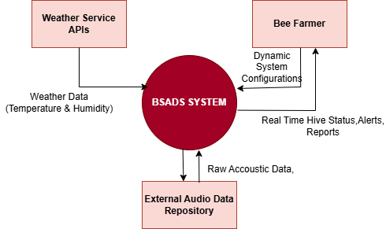
Figure 2. 1 System Context Diagram of the Bee Swarming and Abscondment Detection System
Figure 2.1 illustrates the overall operational context of the Bee Swarming and Abscondment Detection System (BSADS). The diagram presents the system as a single central process and shows its interaction with external entities through defined data flows.
The external entities include:
  - Beehive Sensor Database: A centralized data repository responsible for storing high-resolution raw acoustic signals captured from the hive, as well as associated environmental parameters such as temperature and humidity, where available. This dataset serves as the primary input for signal processing and machine learning models.
  - Weather Service APIs: External data integration services that provide real-time and historical meteorological data (e.g., temperature, humidity, rainfall, and wind patterns). These inputs enhance contextual analysis and improve the robustness and accuracy of predictive models.
  - Bee Farmer (End User): The primary stakeholder interacting with the system, responsible for monitoring hive conditions. The system delivers actionable insights through alerts, analytical reports, and real-time status updates to support informed decision-making.
The diagram demonstrates how acoustic and environmental data flow from the bee hive sensor storage databases into the BSADS for preprocessing and analytical evaluation. External weather data is also integrated into the system to enhance contextual understanding of hive conditions. After preprocessing through noise reduction and feature extraction, machine learning models analyze the processed data to detect abnormal patterns and classify hive states. The resulting real-time status updates, predictive alerts, and analytical reports are transmitted to the Bee Farmer through the mobile application interface.
The diagram further illustrates bidirectional communication, where the Bee Farmer may send alert acknowledgments or configuration settings to the system. Additionally, the system does not directly control or interact with physical hive sensors but relies entirely on externally provided datasets.

2.3 Product Functions
The functional modules described in this section expand upon the high-level pipeline introduced in Section 2.1.2 and provide detailed responsibilities for each stage of the system.
The BSADS architecture is organized into distinct functional modules, each responsible for a specific stage of the data processing and decision-support pipeline. These modules operate in coordination to transform raw hive datasets into meaningful analytical outputs, visual insights, and actionable recommendations for beekeepers.
Specifically, the system comprises the following functional modules:

Data ingestion & preprocessing
This module is responsible for acquiring raw datasets from existing hive monitoring platforms and preparing them for analytical processing. Since raw data may contain inconsistencies, noise, or incomplete records, preprocessing is necessary to ensure reliability and analytical accuracy.
Functions include:
- Retrieval of stored acoustic and environmental datasets
- Validation of data completeness, structure, and integrity
- Noise filtering and removal of corrupted or duplicate entries
- Normalization and standardization of data formats
- Segmentation of data into analyzable intervals

Data preprocessing and machine learning
This module performs computational analysis on the processed datasets to detect behavioral patterns associated with swarming and abscondment. It extracts relevant features and applies trained machine learning models to determine the operational state of the hive.
Functions include:
- Extraction of acoustic frequency features (e.g., dominant frequencies, band energy, spectral centroid, spectral flux variations, temporal characteristics)
- Correlation of available environmental parameters (e.g., temperature and humidity)
- Classification of hive states into:
  - Normal
  - Pre-swarm
  - Swarm
  - Abscondment
  - Uncertain

Visualization and Notification
This module translates analytical outputs into user-friendly representations accessible through the mobile application. It ensures that complex analytical results are presented in an interpretable and actionable format.
Functions include:
- Presentation of hive condition analytics via dashboards
- Display of behavioral trends and risk indicators
- Generation of predictive alerts upon detection of abnormal patterns

Advisory Support
This module provides decision-support guidance based on the classified hive state. It assists beekeepers in taking appropriate and timely action to prevent colony loss.
Functions include:
- Provision of recommended interventions based on detected hive conditions
- Guidance on preventive measures and best management practices

Geospatial Mapping
This module provides spatial awareness of hive conditions by linking analytical results to geographic locations.
Functions include:
- Visualization of hive locations on a digital map
- Spatial representation of colony risk levels and status indicators

Connectivity & Synchronization
This module ensures continuity of system access during temporary network interruptions.
Functions include:
- Local access to previously synchronized analytical results and alerts
- Storage of updates during offline operation
- Automatic synchronization with the central platform once connectivity is restored
Additionally, historical data and classification results are stored to support long-term performance evaluation and research.

2.4 User Classes and Characteristics
The BSADS is intended for multiple user categories, each with distinct roles, responsibilities, and interaction requirements. The system design accommodates varying levels of technical expertise to ensure usability and effectiveness across all user groups.

2.4.1. Beekeepers (End Users)
Beekeepers are the primary users of the system. They interact with the BSADS through the mobile application to monitor hive conditions, receive alerts, and review historical data. Beekeepers may possess limited technical knowledge; therefore, the user interface is designed to be intuitive, visually informative, and easy to navigate. The system provides clear notifications and simplified data visualizations to support timely decision-making without requiring advanced technical skills. These also administer the system through configuring the system, managing user access and settings, among others.

2.4.2. Researchers and Analysts
Researchers and analysts use the system to access aggregated and historical data for research, evaluation, and model improvement purposes. This user class typically has advanced analytical skills and may interact with exported datasets or analytical dashboards. The system supports this group by maintaining structured data storage and providing access to long-term records necessary for evaluating hive behavior and machine learning model performance.
Table 2. 1 Users of the BSADS system and their technical expertise level
User Class | Primary Interaction Method | Technical Expertise Level
Beekeeper | Mobile Application | Low to Medium
Researcher | Data Analytics and Reporting Tools | High

2.4 Operating Environment
The BSADS operates within a cloud-centered software environment that supports data storage, machine learning analytics, visualization services, and mobile access. The operating environment consists of the following components:
- Cloud Data Storage Environment
- Machine Learning Processing Environment
- Visualization and Backend Support Environment
- Mobile Application Environment
- Communication Infrastructure
Each environment above is as described below.

2.4.1. Cloud Data Storage Environment
The system operates on pre-collected acoustic datasets, some of which may optionally include corresponding environmental parameters such as temperature and humidity. These datasets are stored in a cloud-based storage infrastructure. The cloud storage environment provides:
- Centralized storage of acoustic and environmental datasets
- Scalable database services for structured and unstructured data
- Secure data access control mechanisms
- Long-term archival for historical analysis
This environment forms the starting point of the BSADS data pipeline, as the system retrieves raw datasets directly from this storage layer.

2.4.2. Machine Learning Processing Environment
The analytics component operates within a cloud-based computational environment that supports preprocessing and machine learning inference. This environment provides:
- Data preprocessing capabilities (cleaning, normalization, feature extraction)
- Execution of trained machine learning classification models
- Computational resources for batch or near-real-time analysis
- Model storage and version management
The machine learning environment is responsible for transforming raw hive datasets into classified operational states (Normal, Pre-swarm, Swarm, Abscondment, or Uncertain).

2.4.3 Visualization and Backend Support Environment
The system includes backend services that act as an intermediary between the analytics engine and the mobile application interface. This environment provides:
- Application Programming Interfaces (APIs) for data access
- Business logic for alert generation
- Dashboard data preparation
- Secure authentication and authorization services
It ensures that analytical results are structured and delivered efficiently to end users.

2.4.4 Mobile Application Environment
The mobile application operates on Android-based smartphones and serves as the primary user interface for beekeepers and system stakeholders. The mobile environment supports:
- Dashboard visualization of hive status
- Alert notifications and advisory messages
- Access to historical trends and reports
- Secure user authentication
Internet connectivity is required for real-time data synchronization, although limited offline access may be supported for previously retrieved results.

2.4.5 Communication Infrastructure
The system relies on internet-based communication networks to enable interaction between cloud services and client applications. The communication infrastructure supports:
- Secure data transfer using encrypted protocols
- API-based communication between backend services and mobile devices
- Synchronization of analytical results and alerts
The design accounts for intermittent connectivity by allowing delayed synchronization when network access becomes available.

2.5 Design and Implementation Constraints
The design and implementation of the BSADS are subject to several technical, operational, and project-related constraints that influence architectural decisions, system behavior, and achievable performance. These constraints are enumerated as follows:
- Computational and Storage Constraints:
The BSADS relies on cloud-based processing for data analysis and machine-learning inference due to the limited processing power, memory, and storage available on end-user mobile devices. Smartphones are therefore used primarily for visualization, alert delivery, and user interaction rather than for executing computationally intensive analytics or machine learning models. To address these limitations, trained models are deployed within the cloud environment, and only summarized results, alerts, and selected historical data are synchronized to the mobile application to minimize storage and processing overhead.
- Communication and Connectivity Constraints:
The system depends on internet connectivity to enable communication between cloud services and the mobile application. In rural or remote apiary locations, network instability or limited connectivity may affect real-time access to analytics and alerts. To mitigate this constraint, the system supports intermittent connectivity by allowing delayed synchronization and limited offline access to previously retrieved results, with automatic updates once network access is restored.
- Data Quality and Model Accuracy Constraints:
The accuracy of the machine learning models is influenced by the quality, completeness, and representativeness of the available datasets. Some acoustic datasets may lack corresponding environmental parameters, and certain hive states, such as abscondment, may be underrepresented. These factors can limit classification confidence and predictive accuracy. As a result, the system incorporates uncertainty handling in classification outputs and is designed to support future model retraining as additional and higher-quality data become available.
- Advisory Scope Constraints:
The advisory component provides guidance based on detected hive states and predefined knowledge rules. However, it cannot account for all possible biological, environmental, or management scenarios encountered in real-world beekeeping practices. The advisory outputs are therefore intended to support informed decision-making rather than replace expert judgment or beekeeper experience.
- Project and Resource Constraints:
Project-related limitations, including development time, budget, availability of labeled datasets, and deployment resources, influence system scalability, model complexity, and the extent of real-world validation during the implementation phase.
The functional decomposition presented in this chapter forms the foundation for the architectural design described in Chapter 3, where each functional module is mapped to a corresponding subsystem to ensure consistency between system functionality and structural implementation.

3. SYSTEM ARCHITECTURE

3.1 Architectural Design
The BSADS is designed using a modular, layered architecture in which system responsibilities are partitioned into well-defined and cooperating subsystems. This architectural approach is guided by the need to separate concerns related to data integration, analytical processing, persistent storage, system coordination, and user interaction. Such separation enhances system maintainability, scalability, fault isolation, and supports independent evolution of system components over time.
The architectural design presented in this section is derived directly from the functional decomposition defined in Chapter 2. Each subsystem corresponds to one or more functional modules, thereby ensuring consistency and traceability between system functionality and structural implementation.
At a high level, BSADS is decomposed into six major subsystems:
- External Hive Monitoring Interface
- Data Integration and Communication Subsystem
- Backend Coordination Subsystem
- Data Processing and Machine Learning Subsystem
- Cloud Data Management Subsystem
- Application Presentation Subsystem
Each subsystem is assigned clearly defined responsibilities and interacts with other subsystems through well-defined interfaces. This structured decomposition ensures that data flows in a controlled and predictable manner across the system while maintaining clear boundaries between responsibilities.

3.1.1 Functional to Architectural Mapping
To ensure consistency between the system’s functional design (Chapter 2) and its architectural structure, each functional module is mapped to a corresponding subsystem. This mapping demonstrates how high-level system functionalities are realized within the architectural components.
Table 3. 1: Functional modules to architectural subsystem mapping
Functional Module (Section 2.3) | Corresponding Subsystem (Chapter 3)
Data Integration & Preprocessing | Data Integration and Communication Subsystem
Data Processing & Machine Learning | Data Processing and Machine Learning Subsystem
Visualization & Notification | Application Presentation Subsystem and Backend Coordination Subsystem
Advisory Support | Backend Coordination Subsystem
Geospatial Mapping | Application Presentation Subsystem
Connectivity & Synchronization | Backend Coordination Subsystem and Application Presentation Subsystem
Data Storage (implicit) | Cloud Data Management Subsystem

Table 3.1 presents the mapping between the functional modules defined in Chapter 2 and the corresponding architectural subsystems in Chapter 3, illustrating how system functionalities are realized within the structural design of BSADS.
This mapping ensures that all functional requirements identified in Chapter 2 are fully represented within the system architecture, thereby maintaining structural and behavioral consistency across the system design.

3.1.2 Subsystem Responsibilities

External hive monitoring interface
The External Hive Monitoring Interface represents the boundary between BSADS and external hive monitoring platforms. It provides access to pre-collected acoustic datasets and, where available, associated environmental parameters such as temperature and humidity. This subsystem operates outside the direct control of BSADS and serves strictly as the source of input data. The system does not directly interact with or control physical sensing hardware but relies entirely on externally generated datasets.

Data ingestion & communication subsystem
This acts as the controlled entry point into the system. It is responsible for receiving datasets from external monitoring platforms and ensuring that incoming data is valid, secure, and properly structured before further processing. Its primary responsibilities include:
- Receiving datasets from external monitoring systems
- Validating dataset structure and metadata
- Enforcing authentication and access control
- Assigning unique identifiers to incoming records
- Forwarding validated datasets to backend services

Backend coordination subsystem
This serves as the central orchestrator of system operations. It manages workflow execution and coordinates interactions between different subsystems, ensuring that data flows correctly through the processing pipeline. Its responsibilities include:
- Routing validated datasets to preprocessing pipelines
- Triggering machine learning inference
- Managing alert-generation logic
- Providing RESTful APIs for client communication
- Coordinating interactions between analytics and storage layers
This subsystem acts as the central controller of the system.

Data processing & machine learning subsystem
This forms the analytical core of BSADS. It is responsible for transforming raw acoustic datasets into meaningful insights through a series of computational processes.
This subsystem performs preprocessing operations such as noise reduction and signal normalization, extracts relevant acoustic features, integrates environmental parameters where available, and applies trained machine learning models to classify hive conditions. The output consists of hive-state classifications (e.g., Normal, Pre-swarm, Swarm, Abscondment, or Uncertain) along with associated confidence scores. Through these processes, the subsystem converts raw hive recordings into structured operational intelligence.

Cloud data management subsystem
This subsystem provides persistent storage and data organization capabilities for the system. It maintains all critical data required for both real-time operations and long-term analysis. It maintains:
- User and hive records
- Raw dataset metadata
- Extracted feature vectors
- Inference results
- Alert records and logs
It supports both real-time retrieval and long-term historical analysis.

Application presentation subsystem
The application presentation subsystem represents the user-facing layer of the system, primarily implemented through a mobile application. It is responsible for presenting analytical outputs in an accessible and user-friendly format. It is responsible for:
- Displaying hive state classifications
- Presenting dashboards and historical trends
- Delivering alerts and advisory messages
- Supporting secure user authentication
It interacts exclusively with backend APIs and does not perform analytical processing locally.

3.1.3 Subsystem collaboration
The subsystems within BSADS operate in a coordinated and sequential manner to form a complete data processing and decision-support pipeline. The interaction begins with the External Hive Monitoring Interface providing raw datasets to the system. These datasets are received and validated by the data integration and communication subsystem before being forwarded to the Backend Coordination Subsystem.
The backend coordination subsystem then triggers preprocessing and analytical operations within the data processing and machine learning subsystem. Once analysis is complete, the resulting classifications and associated data are stored within the cloud data management subsystem.
Finally, the application presentation subsystem retrieves the processed results through backend APIs and presents them to the end user in the form of dashboards, alerts, and advisory messages. Throughout this process, the backend coordination subsystem acts as the central mediator, ensuring controlled and consistent data flow between all subsystems.
This coordinated interaction ensures that BSADS operates as an integrated system capable of transforming raw hive datasets into actionable insights for beekeepers while maintaining architectural consistency and data integrity.

3.1.4 BSADS High-Level Architectural Diagram
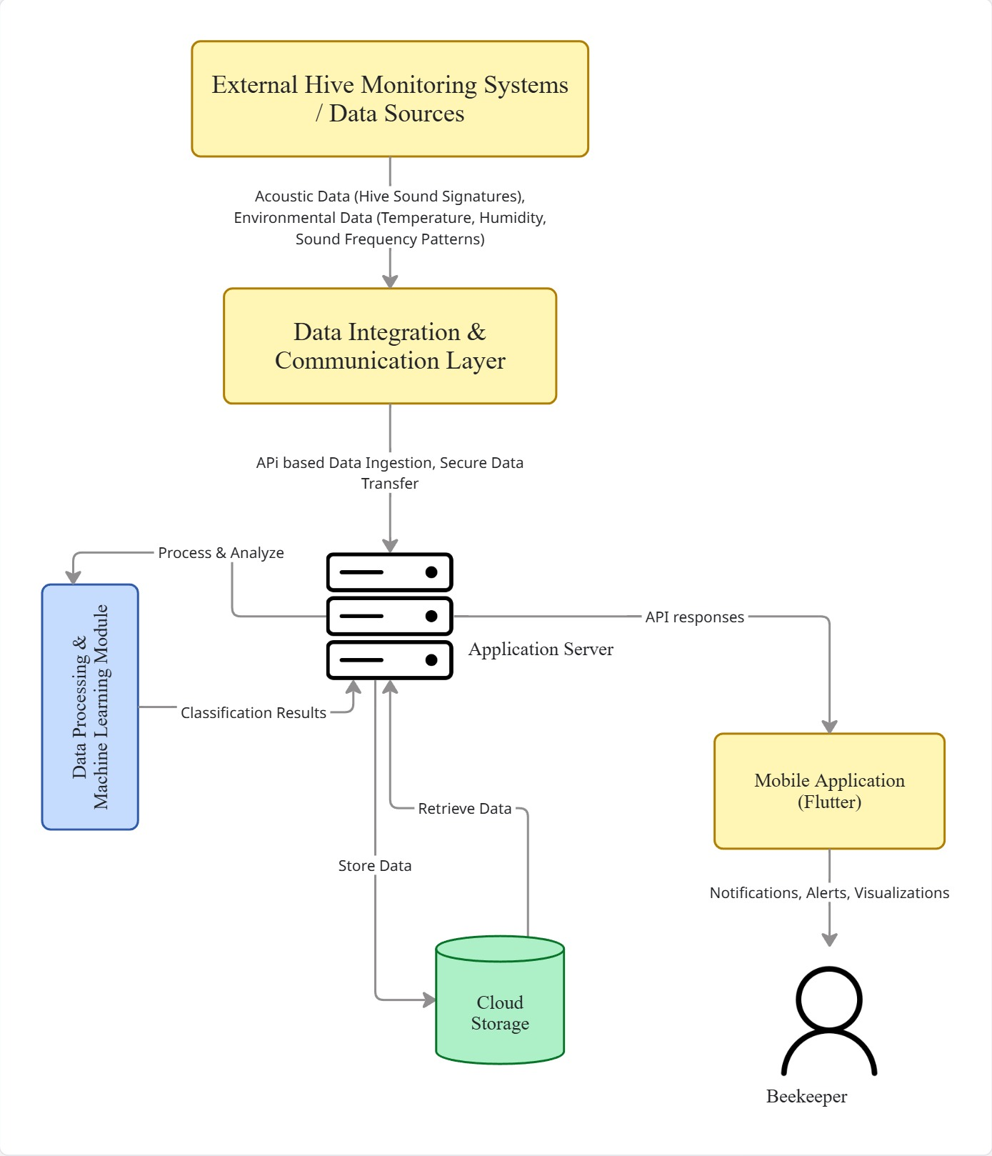
Figure 3. 1 High-Level Architectural Diagram for BSADS
Figure 3.1 illustrates the high-level architecture of the BSADS, showing the interaction between the external hive monitoring node or data source, communication layer, backend services, machine learning module, database, and mobile application.

3.2 Decomposition Description
This section presents a functional decomposition of the BSADS. The decomposition refines the high-level architectural structure defined in Section 3.1 into logically cohesive processing units and associated data repositories. It provides a detailed view of how data flows through the system and how individual processing stages collaborate to produce analytical outputs.
A functional modeling approach is adopted because the behavior of BSADS is primarily driven by sequential data transformation workflows. These workflows begin with external dataset ingestion and progress through preprocessing, feature extraction, machine learning inference, and decision-support processes, ultimately culminating in alert generation and user presentation.
The decomposition is represented using:
- A Context-Level Data Flow Diagram (Level 0 DFD)
- A Level 1 Data Flow Diagram
- A Structural Decomposition Diagram
These representations collectively illustrate system boundaries, internal processing logic, data storage responsibilities, and the relationship between functional processes and architectural components.

3.2.1 Context-Level Data Flow Diagram (Level 0)
At the context level, BSADS is represented as a single processing entity (Process 0) interacting with external entities, as introduced in Section 2.2. This view defines the system boundary and highlights all external interactions.
The external entities include:
- External Hive Monitoring Storage Platform
- Mobile Application User (Beekeeper)
- Weather Service APIs
The External Hive Monitoring Storage Platform provides pre-collected acoustic datasets along with associated metadata such as hive identifiers and timestamps. The Weather Service APIs supply environmental data, including temperature, humidity, and other meteorological parameters that enhance contextual analysis.
The Mobile Application User (Beekeeper) interacts with the system to access hive status information, receive alerts, and review historical reports. The user may also provide inputs such as configuration settings or alert acknowledgments.
Within this context, BSADS functions as a centralized analytical system that ingests external datasets, processes them, and returns actionable insights to the user.

3.2.2 Level 1 Data Flow Diagram
The Level 1 Data Flow Diagram decomposes Process 0 into major internal processes that correspond directly to the functional modules defined in Section 2.3 and the subsystems described in Section 3.1. This ensures consistency between functional behavior and architectural structure.

a) Major Processes
Process 1.0: Data ingestion and validation: This process receives datasets from external hive monitoring storage platforms and, where applicable, weather service APIs. It validates data format, checks metadata completeness, assigns unique identifiers, and ensures that only well-structured data enters the system.
Process 2.0: Data preprocessing and feature extraction: This process transforms validated acoustic datasets into structured representations suitable for machine learning. It performs signal normalization, segmentation, noise reduction, and extraction of relevant acoustic features such as frequency components and spectral characteristics.
Process 3.0: Machine learning inference: This process applies pre-trained machine learning models to the extracted feature vectors in order to classify hive conditions. The output consists of hive-state classifications (e.g., Normal, Pre-swarm, Swarm, Abscondment, or Uncertain) along with associated confidence scores.

Process 4.0: Alert and result management: This process evaluates classification outputs and determines whether alert conditions are met. It generates alerts where necessary, updates historical records, and prepares structured results for downstream consumption.
Process 5.0: Advisory and decision support: This process provides actionable recommendations based on the classified hive state and historical behavioral patterns. It translates analytical results into practical guidance to support beekeeper decision-making.
Process 6.0: Data storage and retrieval management This process manages interaction with system data stores. It ensures that raw datasets, extracted features, inference results, and alert records are properly stored and can be efficiently retrieved for processing, reporting, and historical analysis.

b) Data Stores
D1: Raw dataset repository
Stores validated acoustic metadata and environmental parameters received from external systems.
D2: Analytical results repository
Stores extracted feature vectors, machine learning outputs, hive status history, and generated alert records.

c) Logical Data Flow
The overall data flow within the system follows a structured and sequential pipeline. External hive monitoring platforms and weather APIs provide acoustic and environmental datasets to Process 1.0, where the data is validated and stored in the Raw Dataset Repository (D1).
Process 2.0 retrieves validated data from D1 and performs preprocessing and feature extraction. The resulting feature vectors are then passed to Process 3.0, where machine learning inference is performed to classify hive states.
The classification results are stored in the Analytical Results Repository (D2).
Process 4.0 retrieves these results, evaluates alert conditions, and prepares structured outputs. Process 5.0 further enriches these outputs by generating advisory recommendations.
Finally, the processed results, alerts, and advisory information are made available to the mobile application through backend APIs, enabling user interaction and decision-making.
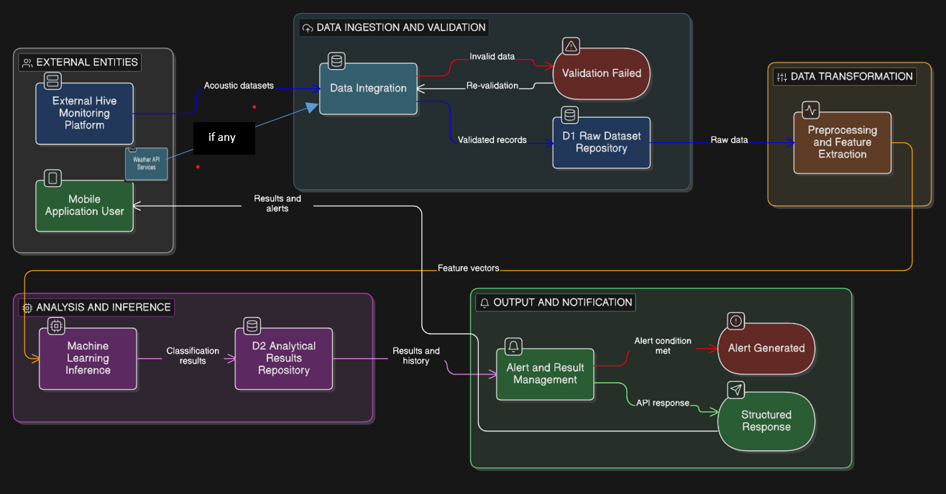
Figure 3. 2 Level 1 Data Flow Diagram for BSADS
Figure 3.2 illustrates the Level 1 Data Flow Diagram’s visual representation of data flow within the system as processes execute and the corresponding subsystems

3.2.3 Structural Decomposition Diagram
While the data flow diagram above represents data movement, the structural decomposition diagram below illustrates the hierarchical organization of the sub system modules.
The BSADS can be structurally decomposed as follows:
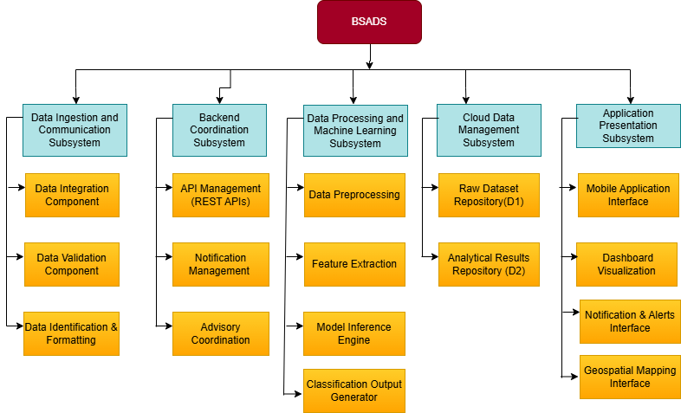
Figure 3. 3 Structural Decomposition Diagram for BSADS
Figure 3.3 illustrates the structural decomposition of the BSADS. The diagram presents a hierarchical breakdown of the system into its major subsystems and their internal components. Each subsystem corresponds to a specific responsibility within the overall system architecture, including data integration, processing, coordination, storage, and presentation. This decomposition ensures clear separation of concerns and demonstrates how high-level system functionality is distributed across structurally independent but interconnected components.

3.2.4 Data Flow Integrity and Consistency
The decomposition ensures a consistent, traceable pipeline:
- External datasets are validated before processing.
- All preprocessing occurs before machine learning inference.
- Classification results are persisted before alert evaluation.
- The mobile application accesses data only through authenticated backend interfaces.
No component bypasses another layer, thereby preserving data integrity and architectural separation of concerns.

3.3 Design Rationale
The modular layered architecture described in Section 3.1 was selected to address the functional, technical, and operational requirements of the Bee Swarming and Abscondment Detection System.

3.3.1 Rationale for Selected Architecture
The system adopts a layered, modular architecture to achieve the following objectives:
- Scalability: New sensors, hives, or machine learning models can be added without major changes to existing components.
- Maintainability: Each subsystem can be updated or replaced independently, reducing system downtime and development complexity.
- Fault Isolation: Failures in one subsystem (e.g., communication issues) do not propagate to other subsystems.
- Flexibility: The architecture supports multiple communication technologies and future system extensions.
Separating data acquisition, processing, and presentation allows the system to handle real-time monitoring while supporting long-term data analysis.

3.3.2 Trade-offs Considered
Several trade-offs were evaluated during architectural selection:
- Cloud-based processing vs. Edge processing:
Cloud-based processing was chosen over full edge-based analytics to reduce computational burden on resource-constrained microcontrollers. This improves model accuracy and simplifies updates, at the cost of dependency on network connectivity.
- Modular architecture vs. Monolithic architecture:
A monolithic design was considered but rejected due to poor scalability and difficulty in maintenance. The modular approach improves system evolution but introduces slightly higher integration complexity.
- Real-time processing vs. Energy efficiency:
Continuous real-time monitoring increases energy consumption. The design balances this by using scheduled sensing intervals and lightweight preprocessing on the hive nodes.

3.3.3 Alternative Architectures Considered
A fully edge-based architecture, where all data processing and machine learning inference occur on the hive node, was considered. However, this approach was not selected due to limited processing power, memory constraints, and increased energy consumption on embedded devices.
A centralized monolithic server architecture was also evaluated but rejected due to limited scalability and reduced fault tolerance.

3.3.4 Conclusion
The selected modular layered architecture provides an optimal balance between performance, scalability, maintainability, and resource efficiency. It supports reliable hive monitoring, accurate predictive analysis, and effective user interaction while allowing future enhancements and integration with broader smart agriculture systems.

4. DATA DESIGN

4.1. Data Description
The data design of the Bee Swarming and Abscondment Detection System (BSADS) defines the structure, organization, and lifecycle of data as it flows through the system. The system operates on pre-collected acoustic datasets retrieved from external storage platforms. As such, BSADS does not control upstream data acquisition but instead focuses on transforming externally stored datasets into meaningful analytical outputs.
Due to the large size and bandwidth requirements of raw audio files, the system does not store audio data directly within the database. Instead, it maintains references (Uniform Resource Identifiers - URIs) to externally stored audio files. This design improves scalability, reduces storage overhead, and enables efficient integration with external storage systems.
The data architecture is organized into three major layers:
- Data Ingestion and Preprocessing Layer
- Machine Learning Processing Layer
- Application and Persistent Storage Layer
These layers collectively ensure data integrity, traceability, scalability, and secure access across backend services and the mobile application.
Additionally, the system distinguishes between:
- Persistent data entities stored in relational databases
- Generated analytical data such as feature vectors, inference results, and processed visual artifacts (such as spectrogram images).

4.2 Data Organization by System Component

4.2.1 Data ingestion & preprocessing
The Data Sanitization Component manages raw datasets retrieved from cloud storage. It validates, cleans, and prepares acoustic and environmental data before feature extraction.
Table 4. 1 Raw Acoustic Data Entity
Field Name | Data Type | Description
audio_id | UUID | Unique identifier for the audio record
hive_id | Integer | Associated hive
source_uri | Varchar(255) | External storage location (file path or URL)
file_format | Varchar(20) | Audio format (e.g., WAV, MP3)
duration_seconds | Decimal(6,2) | Length of recording
captured_at | DateTime | Time of recording
ingestion_timestamp | DateTime | Time data was ingested

Table 4.1 The audio source entity represents externally stored acoustic recordings collected from beehives. Instead of storing raw audio files within the system, this entity maintains references (URIs) to their storage locations. This design minimizes storage overhead and improves scalability. Each audio record is associated with a specific hive and includes metadata such as format, duration, and capture time. These recordings form the primary input to the signal processing and machine learning pipeline.
Table 4. 2 Raw Environmental Data Entity (Optional)
Field Name | Data Type | Description
env_record_id | UUID | Unique identifier
hive_id | Integer | Associated hive
temperature | Decimal(5,2) | Temperature in °C
humidity | Decimal(5,2) | Relative humidity (%)
recorded_at | DateTime | Time of measurement
Table 4.2 Environmental parameters provide contextual information that may improve model accuracy. These records are optional and may not be available for all datasets.

Table 4. 3 Sanitized Audio Metadata Entity (Transient)
Field Name | Data Type | Description
sanitized_id | UUID | Unique identifier
audio_id | UUID | Reference to audio source
noise_reduced | Boolean | Indicates noise filtering
normalized | Boolean | Indicates normalization
segmentation_window_ms | Integer | Segmentation window size
Table 4.3 This entity represents intermediate preprocessing metadata. It is not permanently stored but may be used temporarily for traceability, debugging, and reproducibility during feature extraction..

4.2.2 Machine Learning Processing Component
This component transforms processed acoustic signals into structured representations and generates classification outputs.
Table 4. 4 Feature Vector Entity
Field Name | Data Type | Description
feature_id | UUID | Unique identifier
audio_id | UUID | Source audio reference
hive_id | Integer | Associated hive
mfcc_values | Text | MFCC coefficients
spectral_centroid | Float | Frequency centroid
spectral_bandwidth | Float | Spectral spread
signal_energy | Float | Signal energy
zero_crossing_rate | Float | Signal variation
temperature_normalized | Float | Normalized temperature
humidity_normalized | Float | Normalized humidity
created_at | DateTime | Feature extraction time
Table 4.4 defines the numerical representation of acoustic signals used for machine-learning inference. MFCC coefficients and spectral features form the core predictors of hive state classification. Environmental features are normalized to maintain scale consistency. Feature vectors represent numerical abstractions of acoustic signals used for machine learning inference. Although features can be generated dynamically, they may be stored to support traceability, reproducibility, and future analytical task
Table 4. 5 Model Metadata Entity(optional)
Field Name | Data Type | Description
model_id | UUID | Unique model identifier
model_type | Varchar(50) | Algorithm type
training_dataset_size | Integer | Number of training samples
training_accuracy | Decimal(5,2) | Training accuracy (%)
validation_accuracy | Decimal(5,2) | Validation accuracy (%)
model_version | Varchar(20) | Version label
deployment_date | DateTime | Deployment timestamp
Table 4.5 stores information about trained models. Maintaining model metadata supports reproducibility, version control, and performance evaluation.
Table 4. 6 Inference Result Entity
Field Name | Data Type | Description
inference_id | UUID | Unique identifier
feature_vector_id | UUID | Source feature vector
hive_id | Integer | Associated hive
hive_state | Varchar(30) | Classified hive condition
confidence_score | Decimal(5,4) | Prediction probability (0–1)
inference_latency_ms | Integer | Processing time
timestamp | DateTime | Time of inference
Table 4.6 captures classification outputs generated by the deployed machine learning model. It forms the basis for alert generation and advisory recommendations.
Table 4. 7 Processed Image Entity
Field Name | Data Type | Description
image_id | UUID | Unique identifier
audio_id | UUID | Associated audio
hive_id | Integer | Associated hive
image_type | Varchar(50) | Type (e.g., spectrogram)
image_uri | Varchar(255) | Storage path
generated_at | DateTime | Creation time
Table 4.7 stores references to visual artifacts generated during signal processing, such as spectrograms. These images support visualization, debugging, and interpretability of model behavior.

4.2.3 Application and Persistent Storage Component
This layer supports user management, hive tracking, alerting, and historical analytics in addition to decision support.
Table 4. 8 User Entity
Field Name | Data Type | Description
user_id | Integer | Primary key
full_name | Varchar(30) | User name
telephone_number | Varchar(15) | Contact number
email | Varchar(50) | Unique login email
password_hash | Varchar(255) | Hashed password
role | Varchar(30) | User role
created_at | DateTime | Account creation date
Table 4.7 The user entity represents individuals who interact with the BSADS platform. These include beekeepers and system stakeholders responsible for monitoring hive conditions and responding to alerts. The entity stores essential authentication and identification information such as user credentials, contact details, and system roles.
Table 4. 9 Hive Entity
Field Name | Data Type | Description
hive_id | Integer | Primary key
owner_id | Integer | Foreign key to User
hive_location | Varchar(150) | Hive location
hive_type | Varchar(50) | Hive model
installation_date | Date | Registration date
current_state | Varchar(30) | Latest hive state
Each hive belongs to a single user but may generate multiple sensor audio data and inference records.
Table 4. 10 Alert Entity
Field Name | Data Type | Description
alert_id | UUID | Primary key
inference_id | UUID | Triggering inference
hive_id | Integer | Associated hive
alert_type | Varchar(30) | Swarm / Abscondment
severity_level | Varchar(20) | Alert severity
status | Varchar(20) | Pending / Acknowledged
generated_at | DateTime | Alert time

Table 4.10 The Alert entity represents notifications generated when abnormal hive conditions are detected. Alerts are triggered based on inference results and categorized by type and severity level. This entity enables timely communication with the beekeeper, allowing for rapid response to potential risks such as swarming or abscondment. The alert status field supports tracking whether an alert has been acknowledged or acted upon.
Table 4. 11 Advisory Entity
Field Name | Data Type | Description
advisory_id | UUID | Primary key
inference_id | UUID | Associated inference
hive_id | Integer | Associated hive
advisory_type | Varchar(30) | Preventive / Reactive
created_at | DateTime | Creation time
Table 4.11 The Advisory entity represents a structured decision-support instance generated in response to a specific inference result. It groups a set of recommended actions intended to guide the beekeeper in addressing detected hive conditions. Rather than providing a single recommendation, the advisory serves as a container for multiple actionable steps, ensuring that guidance is organized, comprehensive, and context-specific. This design supports systematic intervention and improves the usability of the system’s decision-support functionality.
Table 4. 12 Advisory Action Entity (Checklist)
Field Name | Data Type | Description
action_id | UUID | Primary key
advisory_id | UUID | FK to Advisory
action_description | Text | Recommended action
priority_level | Varchar(20) | Priority
status | Varchar(20) | Pending / Completed
created_at | DateTime | Timestamp
Table 4.12 The Advisory Action entity defines individual recommended actions associated with an advisory instance. Each advisory may contain multiple actions, forming a checklist that the beekeeper can follow. This structure allows actions to be prioritized and tracked independently, enabling users to monitor progress and ensure that all necessary interventions are completed. It enhances usability by transforming analytical outputs into clear, actionable steps

4.3 Entity Relationship Structure
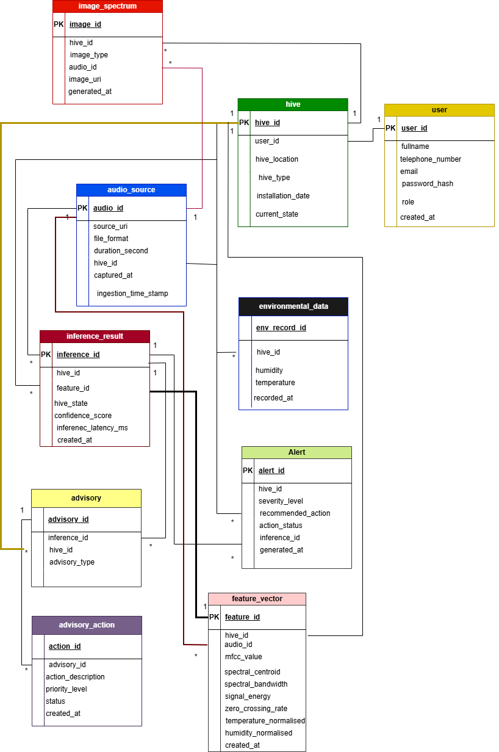
Figure 4. 1 illustrates the logical relationships among core persistent entities.

Each hive generates multiple feature vectors and inference results over time. Alerts are triggered by specific inference records. This relational structure ensures traceability from raw datasets to user-facing notifications.
Transient entities such as sanitized audio metadata are excluded from the ERD since they are not permanently stored.

4.4 Data Integrity and Storage Considerations
The system enforces referential integrity through foreign key constraints between User, Hive, Inference, and Alert entities. Feature vectors may be stored either in structured relational tables or serialized formats depending on storage optimization strategies.

5. COMPONENT DESIGN
The BSADS system adopts a modular and service-oriented design approach in which each component performs a well-defined function within the overall machine-learning processing pipeline. The component design is derived directly from the system architecture described in Chapter 3 and ensures traceability to the functional requirements specified in the Software Requirements Specification (SRS).
The BSADS system is implemented primarily as a backend-driven architecture with supporting mobile client components.

5.1 Component Overview
The major components of the BSADS system include:
- Data Integration Component
- Preprocessing and Feature Extraction Component
- Machine Learning Inference Component
- Cloud Synchronization Component
- System Monitoring and Logging Component
Each component is described in detail in the following sections.

5.1.1 Data Integration Component

Purpose
Acts as the primary ingestion layer for hive-related data. As BSADS does not perform direct sensor acquisition, this component serves as the central gateway for all data transmitted from external monitoring systems.

Inputs
- Pre-recorded hive audio files
- Environmental parameters (temperature, humidity)
- Metadata (hive ID, timestamp, location)

Outputs
- Validated and structured raw data records
- Trigger signal for preprocessing pipeline

Responsibilities
- Accept data streams from storage systems through secure REST endpoints
- Validate file formats and metadata completeness
- Assign unique identifiers to each dataset
- Forward validated data for storage and preprocessing

Processing Logic
- Receive incoming data request
- Validate authentication token
- Check audio file format and size
- Validate metadata fields
- If validation fails:
Reject the request and log an error
Else:
Generate a unique data ID
Store raw data in a repository
Trigger preprocessing pipeline
Figure 5. 1 Process Logic for Data Integration Component

5.1.2 Preprocessing and Feature Extraction Component

Purpose
This component prepares raw hive audio data for machine-learning analysis by cleaning, segmenting, and transforming signals into numerical feature representations.

Inputs
- Raw audio recordings
- Environmental readings

Outputs
- Acoustic feature vectors
- Normalized environmental feature vectors

Responsibilities
- Perform noise reduction
- Normalize signals
- Segment audio windows
- Extract acoustic features (such as MFCCs, spectral features)
- Merge environmental parameters

Processing Logic
- Load raw audio file
- Apply a noise reduction filter
- Normalize amplitude levels
- Segment audio into fixed windows
- For each segment:
Extract MFCC and spectral features
- Normalize environmental parameters
- Merge acoustic and environmental features
- Store feature vectors in the database
Figure 5. 2 Processing Logic for 2 Preprocessing and Feature Extraction Component

5.1.3 Machine Learning Inference Component

Purpose
Manages persistent storage of system data and supports historical analysis.

Inputs
- Raw metadata
- Feature vectors
- Classification results

Outputs
- Structured and indexed database records

Responsibilities
- Maintain relational database integrity
- Store metadata and results
- Support historical queries
- Enable dataset retrieval for retraining

Processing Logic
- Load trained ML model into memory
- Receive feature vector batch
- Apply feature normalization
- Perform inference using the model
- Compute prediction probabilities
- Assign hive state label
- Return classification results

Figure 5. 3 Processing Logic for Machine Learning Inference Component

5.1.4 Cloud Synchronization Component

Purpose
Ensures long-term archival, redundancy, and cross-service availability of processed datasets by synchronizing classification results and analytical summaries with cloud-based storage services.

Inputs
- Classification results
- Analytical summaries
- Processed metadata records

Outputs
- Archived cloud datasets
- Synchronization status logs

Responsibilities
- Perform scheduled synchronization of processed data
- Compress datasets before upload
- Encrypt archived data packages
- Tag synchronized datasets with metadata
- Maintain redundancy and backup copies

Processing Logic
At scheduled intervals:
- Retrieve new classification records
- Compress data files
- Upload to cloud storage
- Update synchronization status
- Log synchronization success or failure

Figure 5. 4 Processing Logic for Machine Learning Inference Component

5.1.5 System Monitoring and Logging Component

Purpose
Provides operational transparency, reliability assurance, and diagnostic support by continuously monitoring system activities and recording significant events across all components.

Inputs
- Data ingestion events
- Preprocessing and inference events
- API access requests
- Synchronization status updates
- System performance metrics

Outputs
- Structured log records
- Error reports
- Performance summaries

Responsibilities
- Capture application-level events
- Record processing errors and exceptions
- Monitor model inference execution
- Track API authentication attempts
- Generate alerts for critical failures

Processing Logic
- Capture event from system component
- Classify event type (info, warning, error, critical)
- Record timestamp and source component
- Store log entry in monitoring repository
- Trigger alert notification if the severity threshold is exceeded
Figure 5. 5 Processing Logic for System Monitoring and Logging Component

6. HUMAN INTERFACE DESIGN

6.1 Overview of User Interface
BSADS provides a mobile application–based user interface through which beekeepers access hive analytics, predictive alerts, and historical behavioral insights. The interface is designed to prioritize usability, clarity, and responsiveness, enabling users with limited technical expertise to interpret system outputs and make informed management decisions.
Upon launching the application, users are presented with a centralized dashboard summarizing the current status of monitored hives. This summary is derived from processed acoustic and environmental data received from integrated hive-monitoring systems. The dashboard displays the predicted hive conditions, such as Normal, Pre-swarm, Swarm, Abscondment, Pest Infestation, or Uncertain, together with key environmental indicators and intuitive visual elements, including status labels and graphical representations.
The application allows users to navigate to detailed analytical views, where historical trends of hive states and associated environmental parameters can be examined over time. This functionality supports pattern recognition and long-term assessment of hive behavior.
In addition, the interface delivers alert notifications when analytical results indicate elevated risks, such as imminent swarming or abscondment. These alerts enable proactive intervention by beekeepers, reducing reliance on frequent manual inspections and improving response timeliness.
Overall, the BSADS user interface emphasizes effective communication of complex analytical results through a simplified and visually structured presentation, supporting practical, data-driven hive management.

6.2 Screen Images
This section presents the proposed user interface screens of the BSADS mobile application. The screens illustrate the complete user interaction flow, from authentication and dashboard access to hive analytics and alert monitoring. The interfaces were designed as mobile application mockups and represent the intended final appearance of the system.

6.2.1 Authentication Screens

i) Splash Screen
Displays the BSADS logo and tagline, providing an entry point to the application.
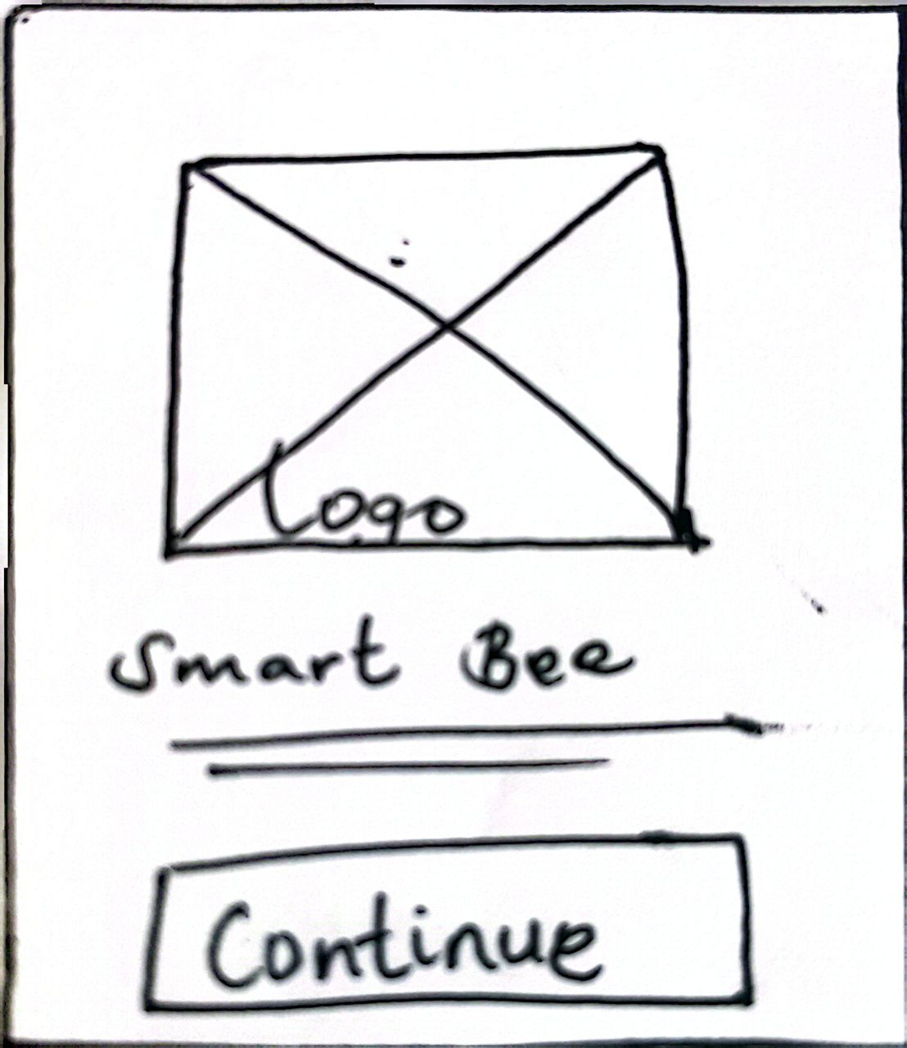
Figure 6. 1 Landing screen for the mobile application
ii) Login Screen
This allows registered users to authenticate using their credentials.
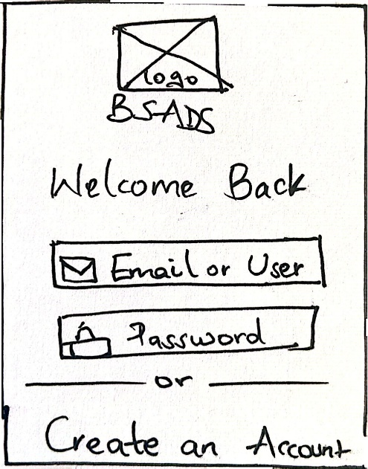
Figure 6. 2 Login screen for the users to access the system
ii) Sign-Up Screen
Enables new users to create an account by providing the required registration details.
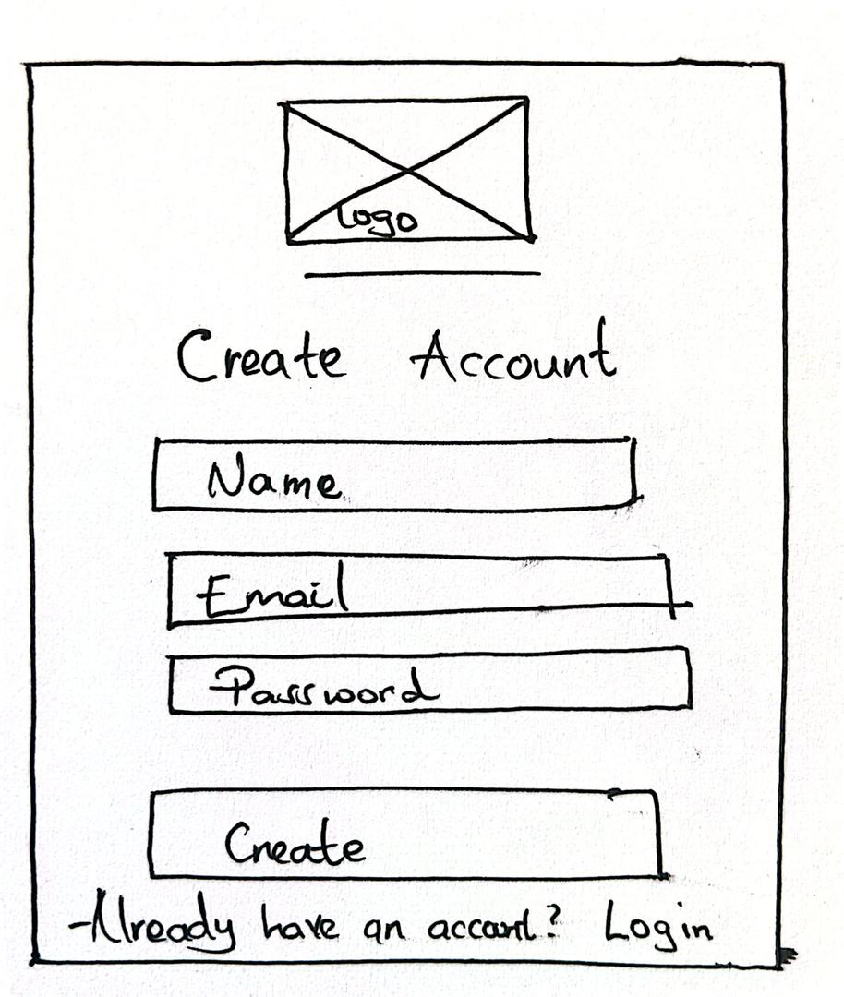
Figure 6. 3 Signup screen for new users to register accounts

6.2.2 Core Monitoring Screens

i) Dashboard Screen
Provides a high-level overview of hive health status, key metrics shown on the left, and on the right, recent alerts.
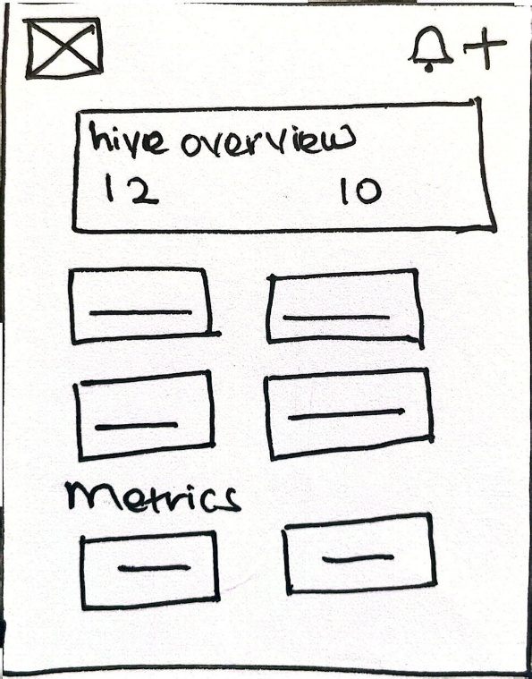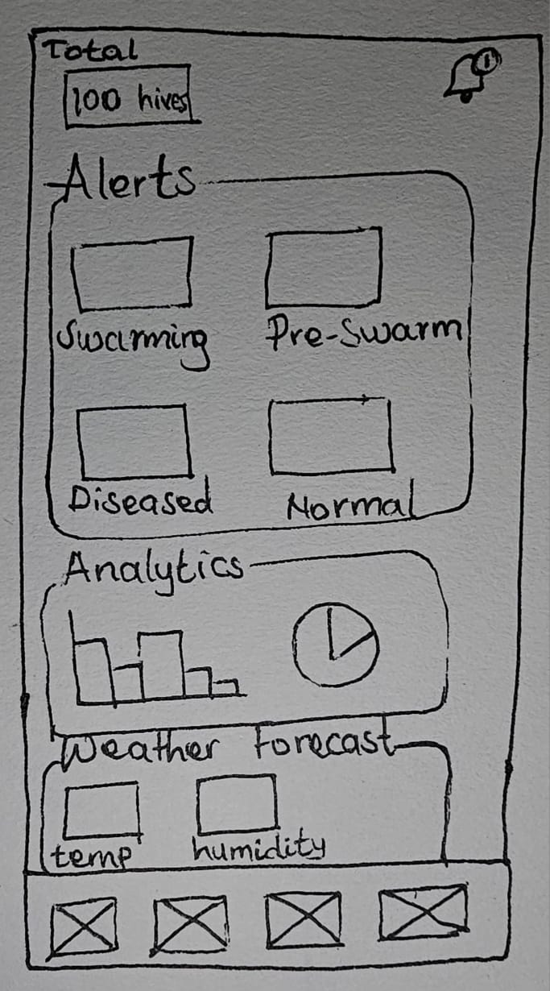
Figure 6. 4 Hive monitoring screen(left) and Dashboard(right)
ii) All Hives Screen
Displays a list of all hives associated with the user, showing their current status and enabling quick navigation to individual hive details.
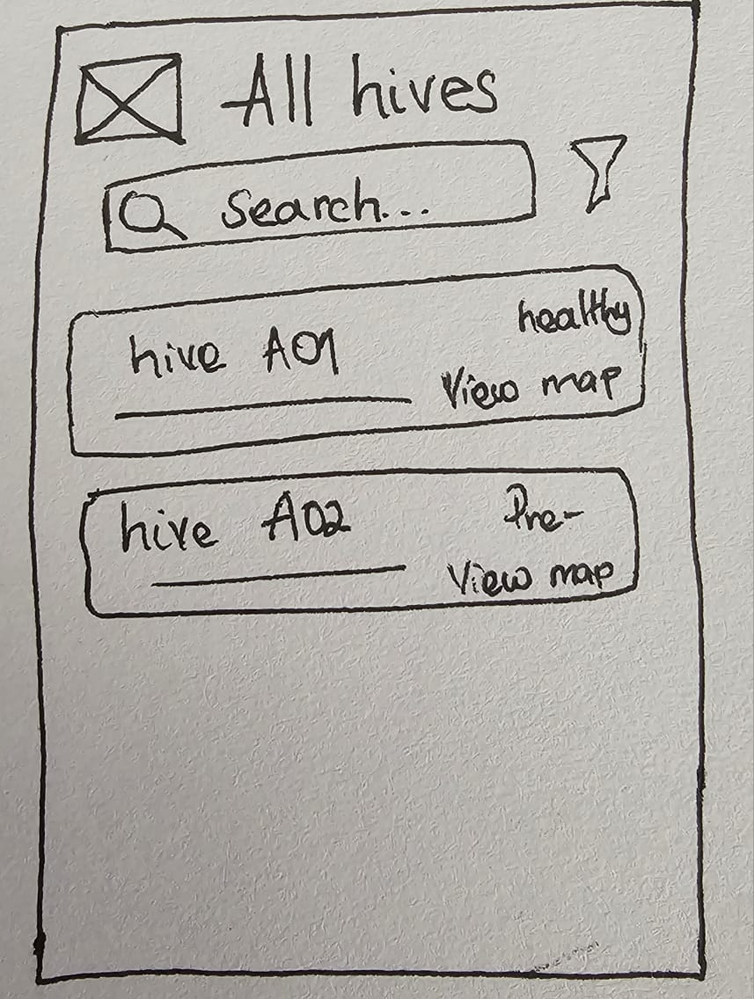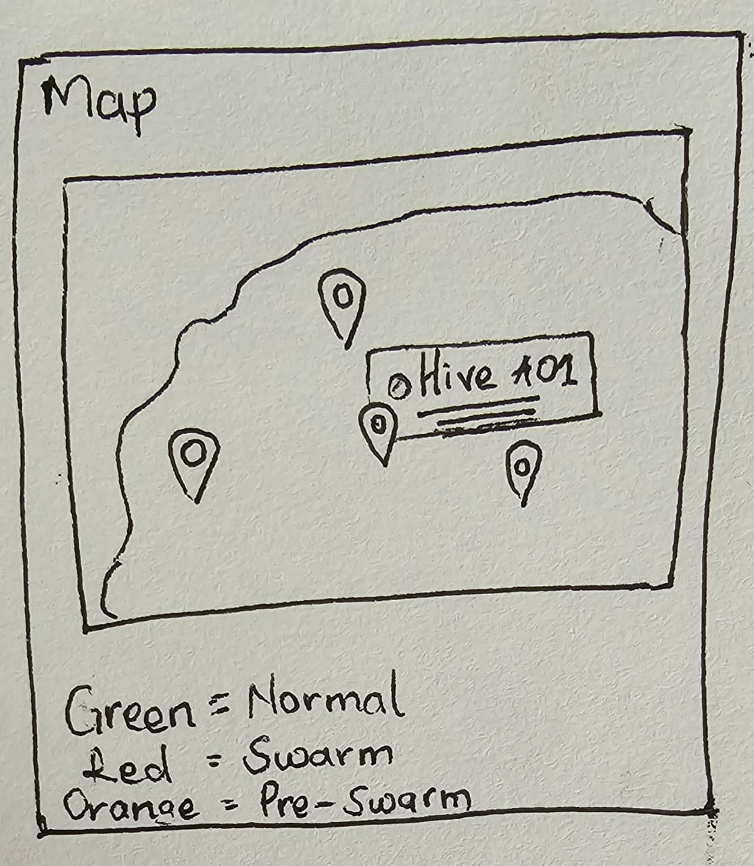
Figure 6. 5 All hives monitoring screen to visualize all hive status(left) and map(right).
iii) Hive Details Screen
Presents detailed analytical information for a selected hive, including predicted hive condition, historical environmental trends, and acoustic activity patterns.

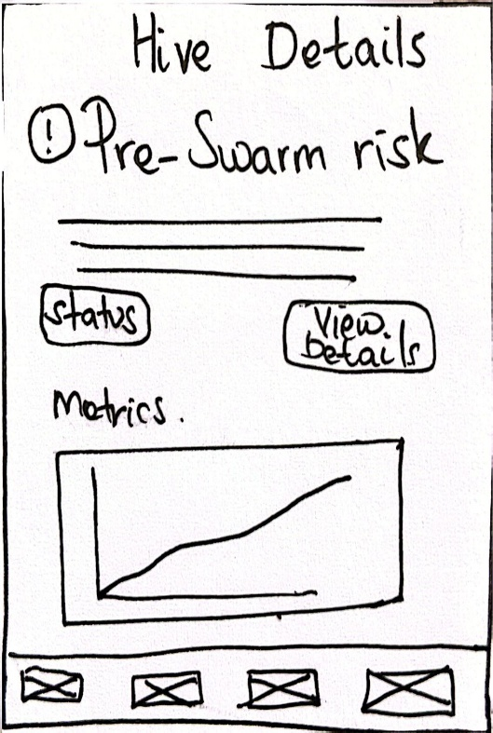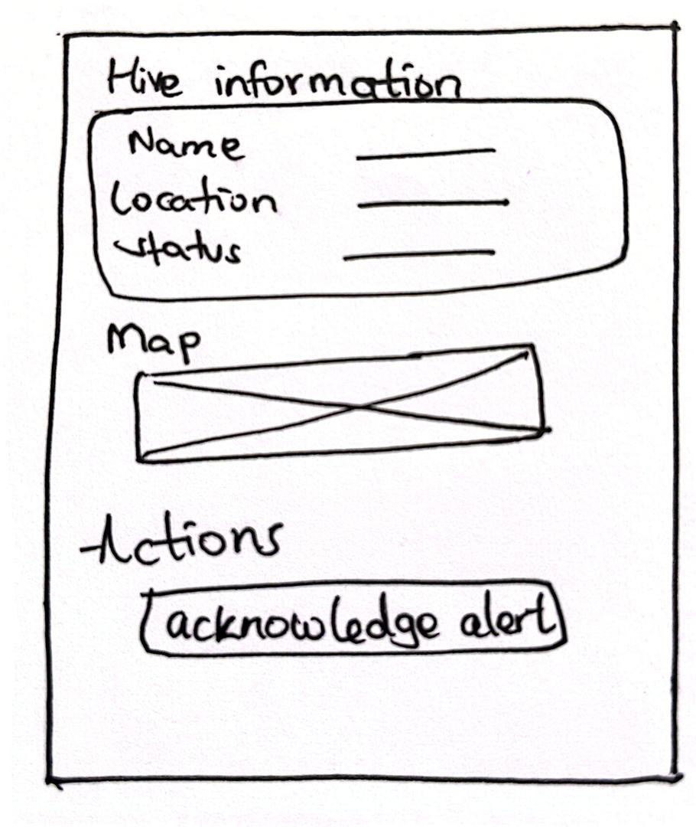
Figure 6. 6 Hive Details screen and information(left) and More hive Details visualizations(right)

6.2.3 Alerts and Notifications Screens
i) Alerts
Displays a list of system-generated alerts related to potential swarming or abscondment risks.
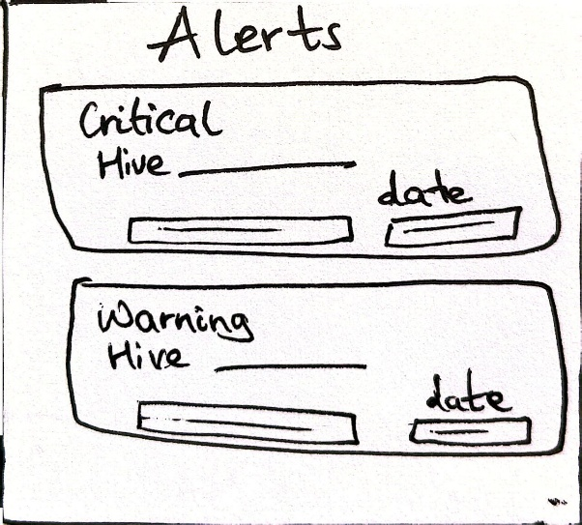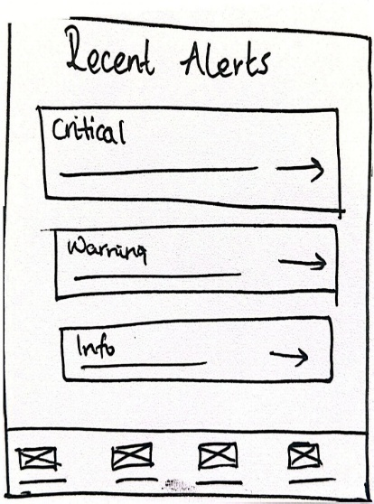
Figure 6. 7 Alerts Summary screen
ii) Alert Details Screen
Provides in-depth information about a selected alert, including risk level, contributing factors, and recommended actions.
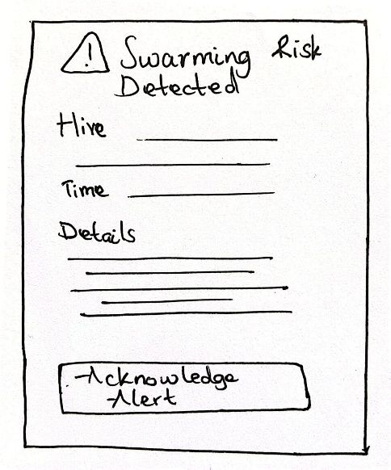
Figure 6. 8 Alert Details screen

6.3 Screen Objects and Actions
These are the main screen objects used within the BSADS mobile application and the actions associated with user interaction on each screen. Screen objects include input fields, buttons, indicators, charts, and navigation elements. These objects enable users to interact with the system and receive feedback from the underlying analytics and machine learning processes.

a) Splash Screen
The splash screen contains the application logo and system tagline.
Action: The screen automatically transitions to the login screen after initialization.

b) Login Screen
This screen contains text input fields for email and password, as well as a login button.
Actions:
- User credentials are submitted for authentication.
- Error messages are displayed for invalid input or failed login attempts.

c) Sign-Up Screen
The sign-up screen includes user registration form fields and a create account button.
Actions:
- User details are validated and stored.
- Successful registration redirects the user to the login screen.

d) Dashboard Screen
The dashboard displays summary metric cards, hive status indicators, and recent alert notifications.
Actions:
- Presents real-time system analytics.
- Automatically updates when new data or predictions are available.

e) All Hives Screen
This screen displays a list of all monitored hives with status labels.
Actions:
- Selecting a hive navigates the user to the hive details screen.

f) Hive Details Screen
The hive details screen includes predictive status indicators, historical charts (temperature, humidity, and acoustic activity), and hive metadata.
Actions:
- Allows users to analyze historical trends.
- Provides insight into predicted swarming or abscondment risk.

g) Alerts Screens
These screens display alert lists, severity indicators, and alert details.
Actions:
- Notifies users of detected risks.
- Allows users to view detailed alert information and acknowledge alerts.

h) Settings Screen
The settings screen contains profile information fields, notification toggles, and system configuration options.
Actions:
- Allows customization of notification preferences and user profile management.

7. REQUIREMENTS MATRIX
This section provides a requirements traceability matrix that cross-references the functional requirements defined in the Software Requirements Specification (SRS) with the system components. The matrix ensures that every functional requirement is addressed by one or more system components.

7.1 Functional Requirements to Components Traceability Matrix
✔ = Component satisfies the requirement
Table 7. 1 Requirements Matrix
SRS Requirement ID | Functional  Requirement  Description | Data Integration Component | Preprocessing & Feature Extraction Component | Machine Learning Analysis Component | Backend  & Data Management Component | Mobile Application Component | Database / Storage Component
FR-1.1 | Integrate acoustic  hive sound data | ✔ |  |  |  |  | ✔
FR-1.2 | Integrate  environmental data (temperature, humidity) | ✔ |  |  |  |  | ✔
FR-1.3 | Handle missing or inconsistent data | ✔ | ✔ |  |  |  | ✔
FR-2.1 | Preprocess acoustic  and environmental data |  | ✔
FR-2.2 | Extract relevant  features from input data |  | ✔
FR-2.3 | Classify hive states  using machine learning |  |  | ✔ |  |  | ✔
FR-2.4 | Store classification  results |  |  |  | ✔ |  | ✔
FR-3.1 | Generate alerts for  swarming risk |  |  | ✔ | ✔ | ✔
FR-3.2 | Generate alerts for abscondment risk |  |  | ✔ | ✔ | ✔
FR-4.1 | Display current  hive status |  |  |  | ✔ | ✔
FR-4.2 | Display historical  hive data and trends |  |  |  | ✔ | ✔ | ✔
FR-4.3 | Allow users to  view alert details |  |  |  | ✔ | ✔
FR-4.4 | Support user  authentication |  |  |  | ✔ | ✔

7.2 Summary
The Requirements Matrix demonstrates that all functional requirements defined in the SRS are fully supported by the system components. Each requirement is mapped to one or more components, ensuring consistency between system requirements and system design.

